API Documentation
User Registration, Catalog, Customers

Overview
This documentation provides details on how to use the User Registration, Catalog and Customers API. The API allows users to
- Register by providing their username, email, and password.
- Get list of products from catalog
- Perform CRUD operations on customers database

Base URL
http://localhost:3000

Endpoints
- Register User: Registers a new user by creating an account with their username, email, and password.
URL: api/register
Method: POST
Request Headers:
- Content-Type: application/json

- Get Product Catalog: Get list of products from Catalog
URL: api/catalog
Method: GET
Request Headers:
- Content-Type: application/json

- Create, Read, Update Delete Customers. Creates a new customer with their username, email, and phone number.
URL: api/customer
Method: POST
URL: api/customer
Method: GET
URL: api/customer/:id
Method: PUT
URL: api/customer/:id
Method: DELETE
Request Headers:
- Content-Type: application/json

Prerequisites
- Node.js and npm installed
- MySQL installed and running

Install Dependencies:
- npm install
- npm install express mysql2
Start the Server: node server.js
Error Handling:
- Errors:
  - 400 Bad Request: The server cannot or will not process the request due to a client error.
  - 404 Not Found: The requested resource could not be found.

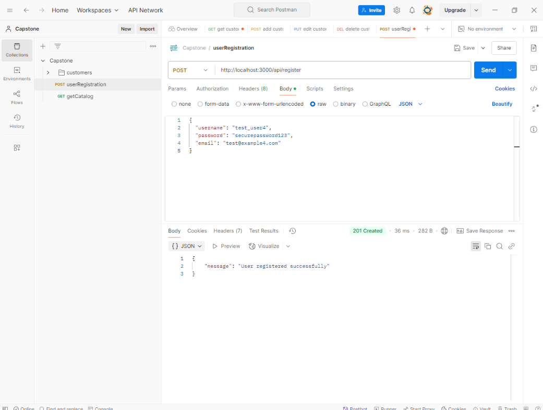
User Registered Successful:

User Already Exists:
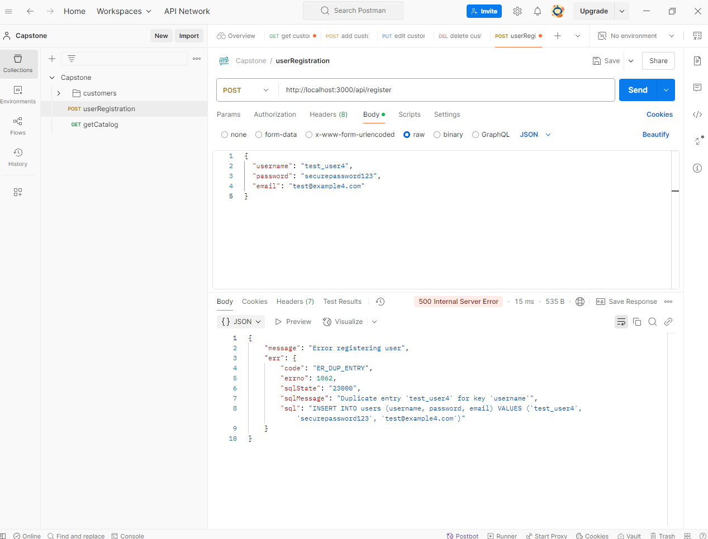

Get Products:
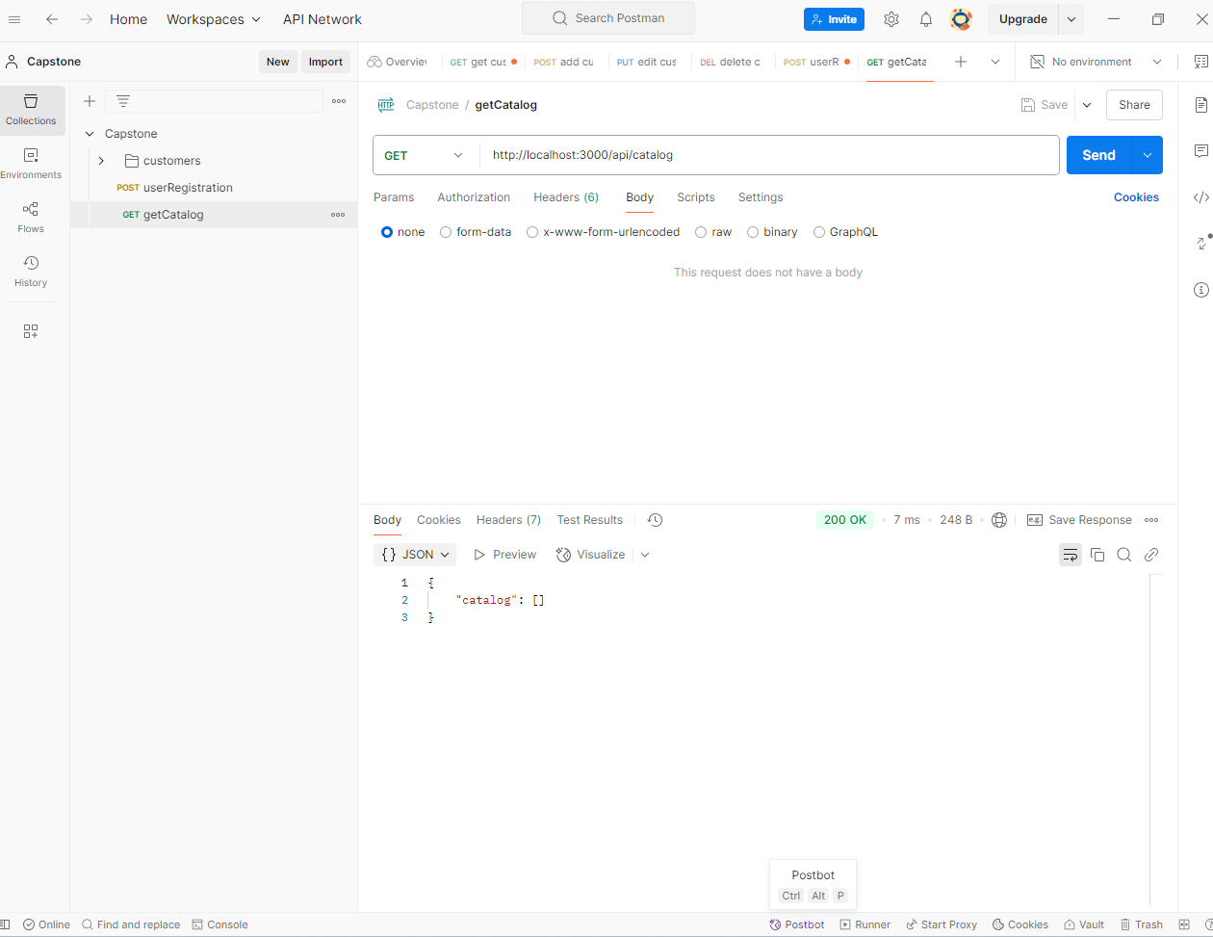

Customer added successfully:
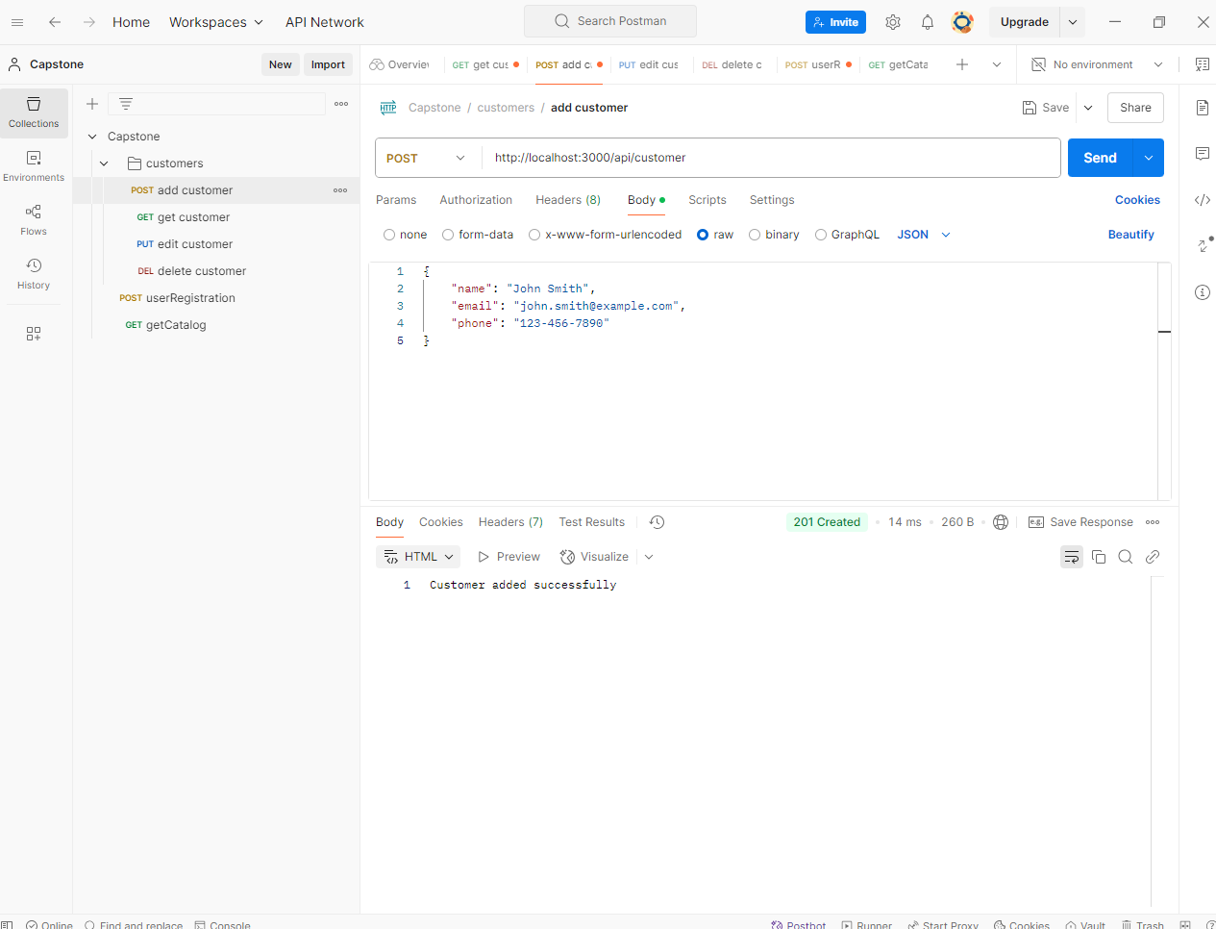

Get Customers:
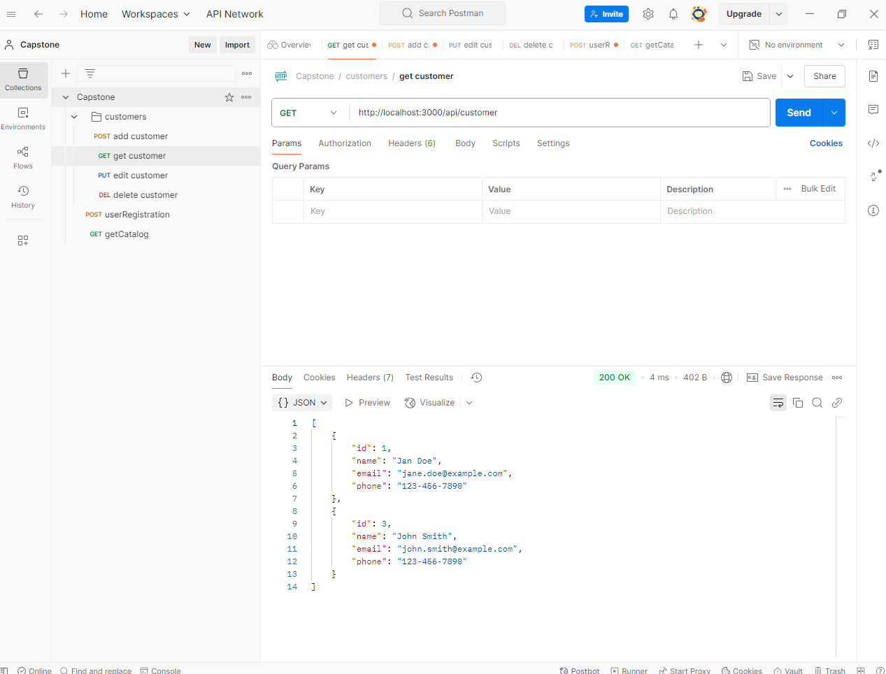

Edit Customer:
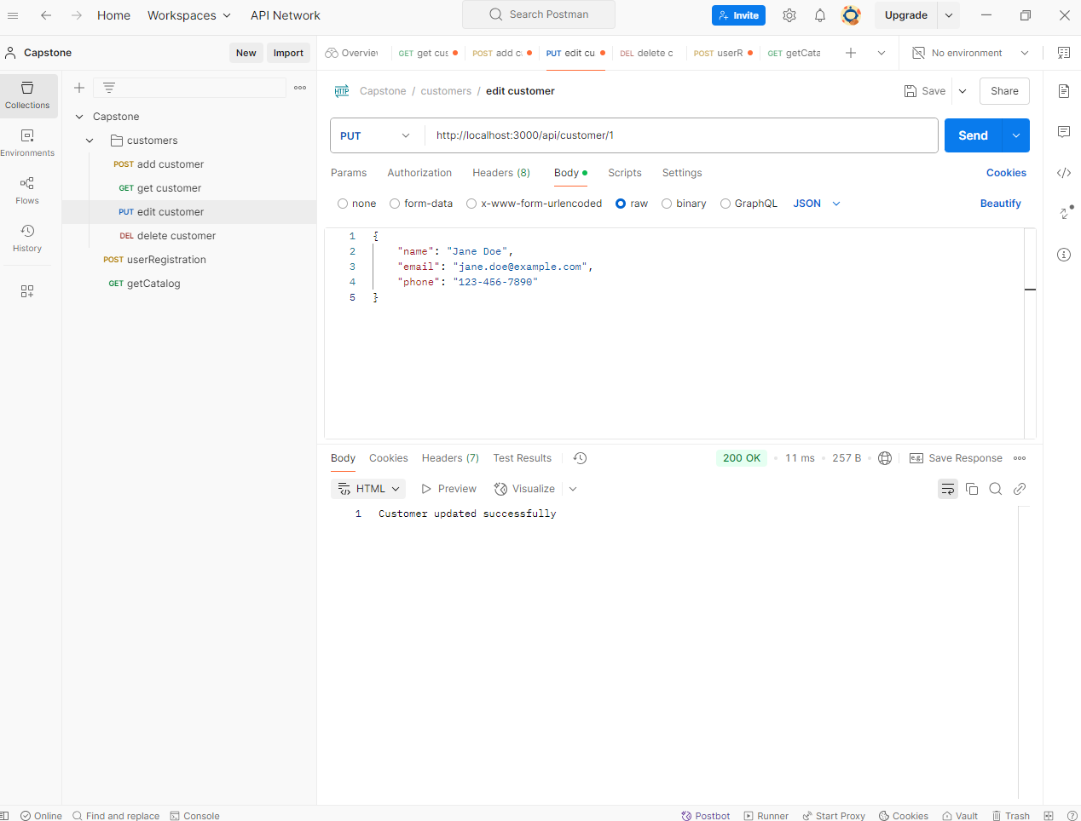

Customer Deleted Successfully:
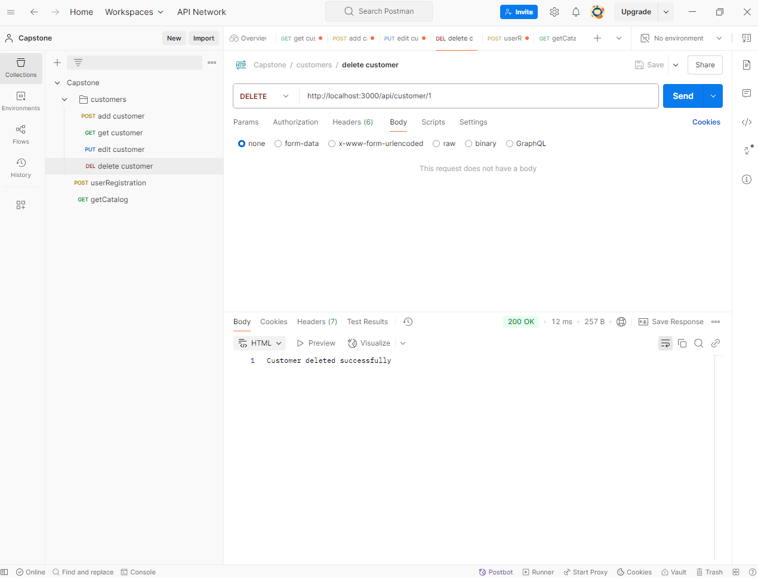

MYSQL Tables
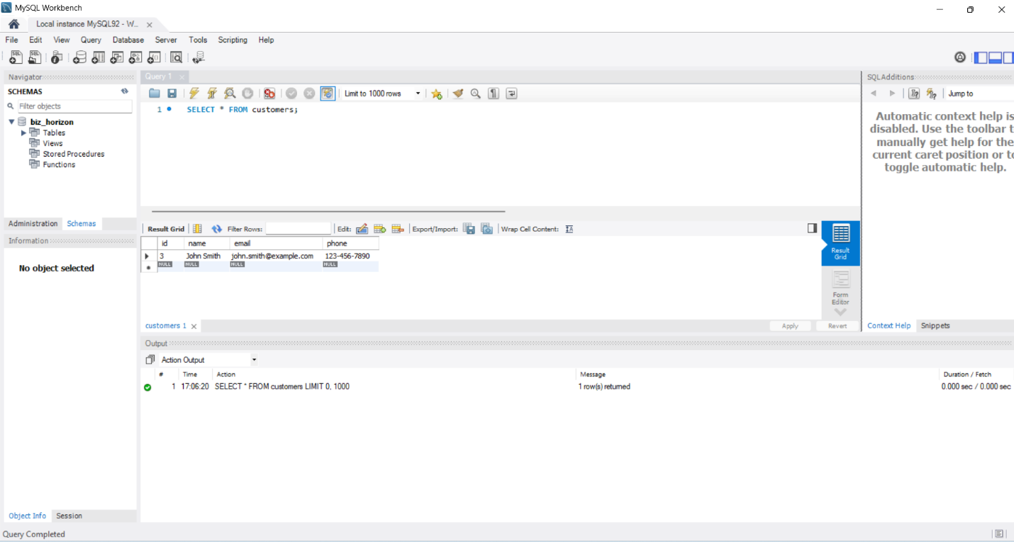
Customers database:

Catalog database:
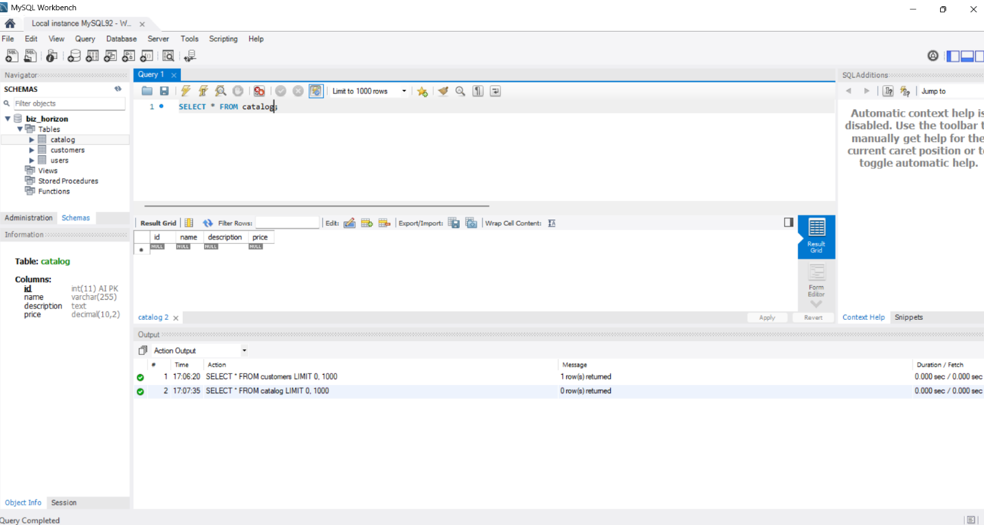

Users Database:
